
V S O
Friends of Vinh Son Montagnard Orphanage

June Newsletter 2019
Volume 16 Issue 6

Contact & Donation Information

FVSO: P.O. Box 9322, Auburn, CA 95604-9322

Email: FriendsofVSO@gmail.com

Web: www.FriendsofVSO.org

In This Issue

- It’s all about caring for their teeth

- Coins for Vinh Son

Each year, for the last 11 years, we’ve recapped the annual Dental Project conducted for the children at each of the Vinh Son and Sao Mai orphanages. This year is no different…..OPEN WIDE!

The 2019 Dental Program

As reported by Sister Martha, Vinh Son Orphanages

Thanks to FVSO and CoVS for their help and support for looking after the children's health, especially for checking and curing the children's teeth yearly. They have supplied funding for this project for the last 11 years. Sister Basile Y NGAT was again in charge of all the moving parts on the ground, making sure that the Dental Program ran smoothly.

Below, I have summarized the program that began with check-in at 8 o’clock in the morning. The 6 Vinh Son orphanages were visited by the dental teams beginning on May 2nd and ending on May 12th.

In the afternoon, there was a dentist’s group who came to check all the children's teeth of Vinh Son 1 orphanage and if the children have some problems with their teeth, the dentists would write their names in a notebook. Then, the following day, they were taken to the dentist's office in Kontum City for treating and curing their bad teeth.

Differently from their fear at the SANH THACH dentist's, most of the children with decayed teeth felt happy to watch TV, read book, eat cakes and biscuit and drink soft drink at the dentist's office while they were waiting to be treated.

The dentists of SANH THACH office are very friendly and helpful, and they always reminded the children how to keep the hygiene of their teeth by brushing and cleaning their teeth after having their daily meals.

In dental program, we have 710 children to check their teeth. The children have some problem with teeth are 668 children until now, they are still treating…not finished yet.

Once again, we give thanks to FVSO and CoVS for helping supply the funds and the dentists, making this year’s program so successful. The children's health of six Vinh Son orphanages has improved greatly, especially their teeth. They are checked and cured so well that they have their happy daily life at their orphanage and they can go to school every day to prepare for their good future lives.

A special Thank-you goes to our partner, CoVS (Children of Vinh Son) who annually contribute half the expense of this program.

Sponsored by FVSO, the Sao Mai Dental program will be conducted by the Pleiku Dentist.


Checking-in and patiently waiting for their turn
Total Cost = $14,900
The annual dental program fee is split between FVSO (Friends) and CoVS (Children)


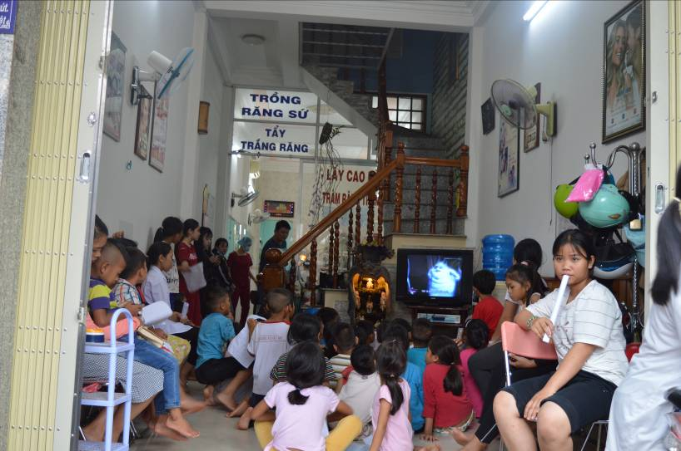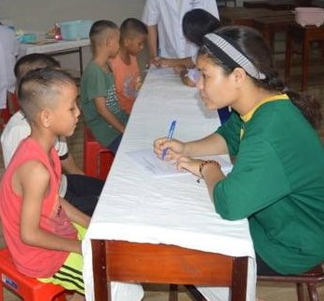



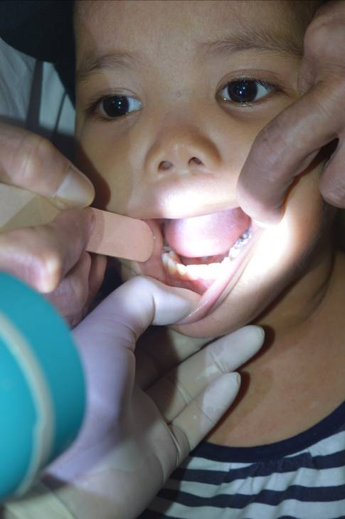
Open wide, let’s see those teeth, say “Ah!”

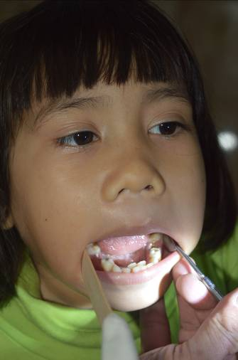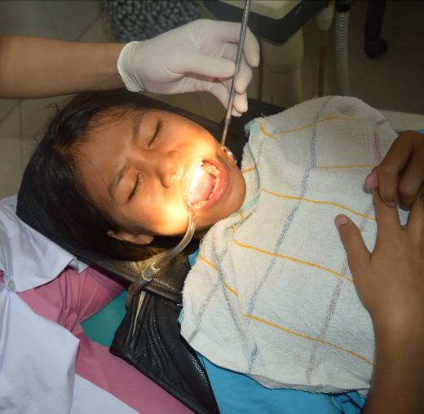

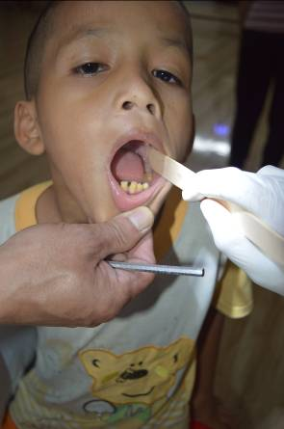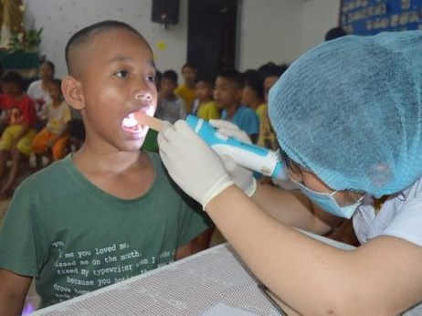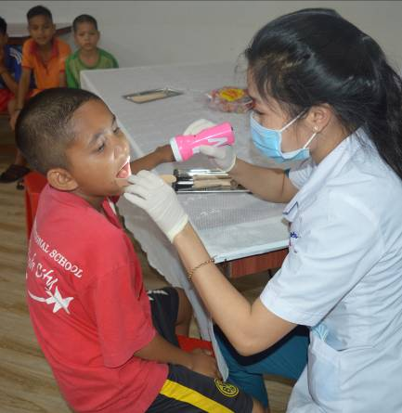



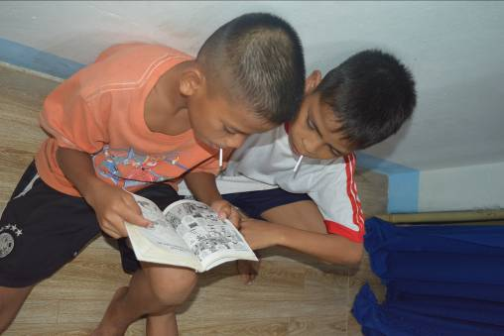

And finally, it’s all over but the smiling and a lolly-pop
Advanced treatment takes place at the Dentist office
Children who require more sophisticated dental work receive that care at the office in Kontum after their preliminary examination
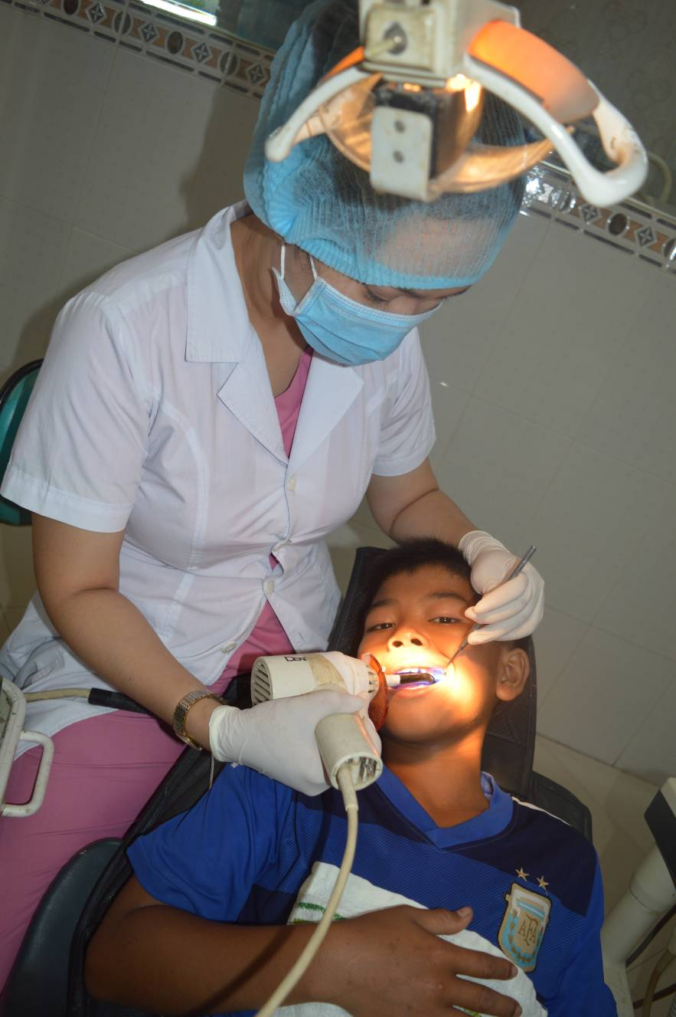
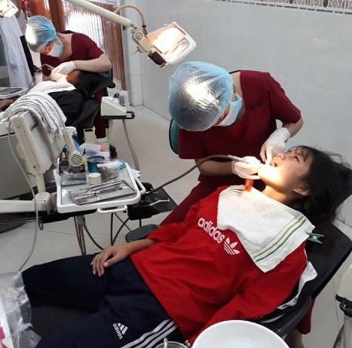

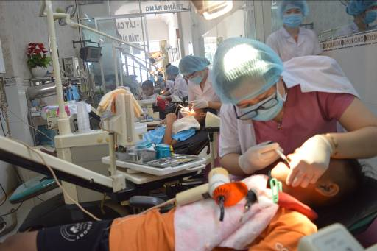
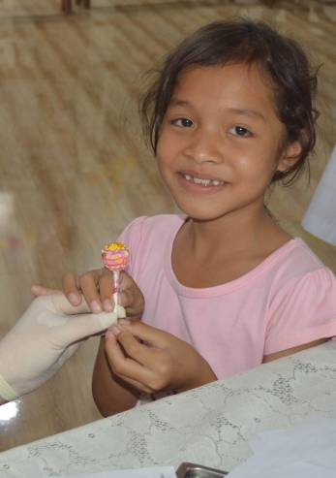
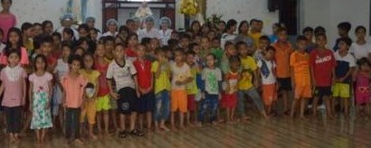

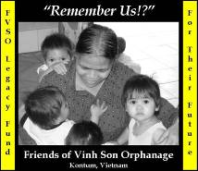

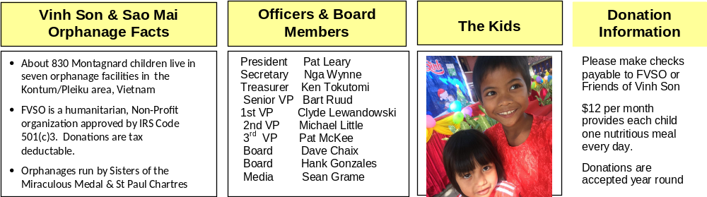
We can help you enlist new benefactors
- Board Members are available to speak at military reunions or to local civilian groups.

- Distribute copies of the monthly FVSO newsletter to your friends and interested groups. Forward the on-line versions and website information via e-mail.

- A Power Point presentation, detailing the FVSO story, is available for your use.

- Tell your personal story. Why are you a member of this team? What would you tell a potential supporter about FVSO? Your history might prompt others to reach out to the children of FVSO.

Legacy Fund Update

The goals are:

$1.0m by Dec 2020
$2.0m by Dec 2025

Total Contributions

$602,890

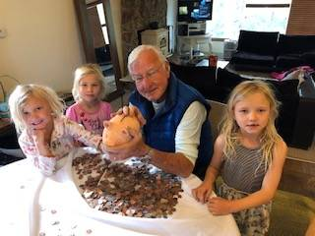
 You shop. Amazon gives.

Words of Wisdom

Nobody has ever measured, not even poets, how much the heart can hold.

-- Zelda Fitzgerald

You don't stop laughing because you grow old; you grow old because you stop laughing.

-- Michael Pritchard

Coins for the Children

Vietnam veteran, Rich Arnold, is pictured below with his very special grand daughters, Isla, Savanah and Kinsley. For the last two years, the girls have been collecting their coins so they can send money to FVSO. As Rich proudly states, “They want to help the Vietnam children.” Indeed, they have….over $100 this year alone! THANKS Girls!!

